# HighScores: Session 8

This tutorial is all in the video – steps to look for are below.

This tutorial shows you how to add a highscore table, add your own name to the table, pass the score across to the game over screen, and update the high score in-game. It will also change to your score if you beat it while still playing.

Things you need to do.

1. Copy the scenes and scripts into your folders as required. Make sure you put my scenes along side yours and my scripts along side yours.
2. 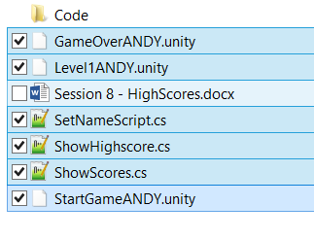
3. Copy the scores UI’s under the Canvas in StartGameANDY into your Start scene.
4. Copy the ShowScores object in in StartGameANDY scene to your Start scene
5. 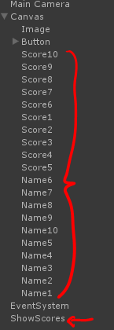
6. Copy the HighScore UI object from my Level1ANDY to your level scene.
7. 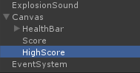
8. Open HealthManager.cs and add this code to your SetHealth function.
9. 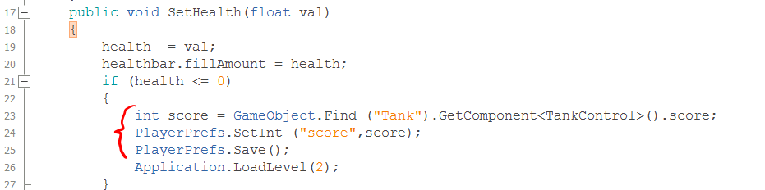
10. Open EnemyController.cs and add this code.
11. 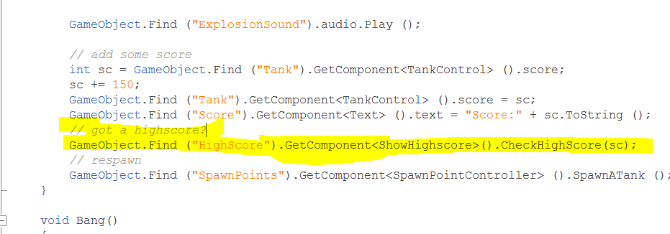
12. Copy the score UI’s in my GameOverANDY scene into your GameOver scene into the Canvas object.
13. Copy the ScoreManager object from GameOverANDY scene into your GameOver scene.
14. 