Tank tutorial Week 7

In this tutorial you will add the ability for the bullets to destroy tanks. They will respawn and if the player gets hit then it will end the game
There are several steps
- The player can take damage
- The enemy can take damage
- The game goes to game over if the player dies.

Player takes damage.
At this stage the enemy can’t hit you but you can knock them.
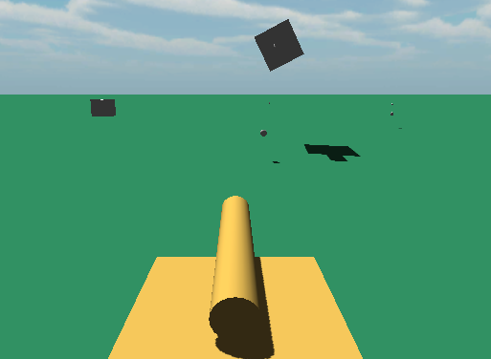
You will add a HUD to track player health and score.
- Create a new folder called UI under Asset in the Project window
- Import the “healthFill.png” by right clicking on the UI folder, click on Import New Asset and load the graphic from this session’s folder.
- Change it’s type to Sprite and hit Apply
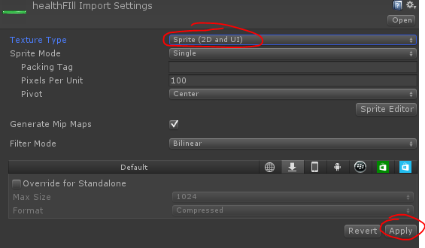
- Right click on the grey space in the hierarchy to add a Slider.
- Under that create a Slider (UI-Slider) and move the Fill Area out plus image underneath – delete the rest. The left images becomes the one on the right when done.
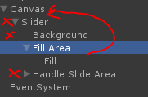 Becomes -> 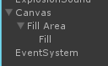
- Rename Fill Area to HealthBar
- Click on the Fill image and change the Image Type to “Filled”
- Change the Source image to healthFill
- Then you will be able to set Fill Method to Horizontal and the slider will control the fill amount.
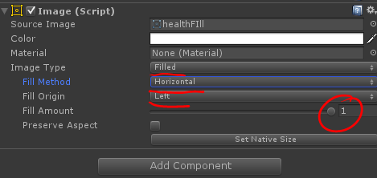
- Next click on the HealthBar (used to be called Fill Area – the root of the Fill graphic) set it’s Rect Transform to Upper Left (Hold Shift and Alt then left click)
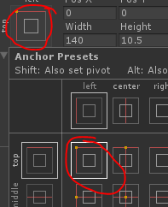
- Make sure your Game view is set to 16:9 not Free Aspect.
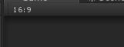
- Adjust the HealthBar’s posX, posY and scale X/y to fit into screen as required.
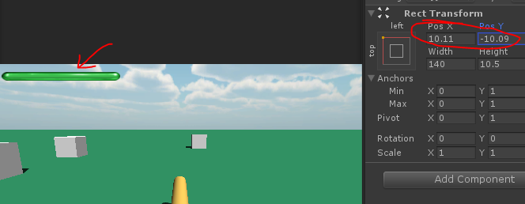
- Click on Canvas and then on Add Component and create a new C# script called HealthManager.
- Add this code.
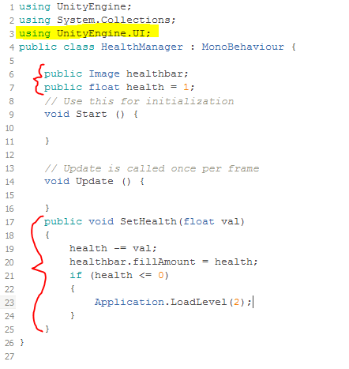
- Save and flick back to Unity.
- Drag the Fill into the slot provided.
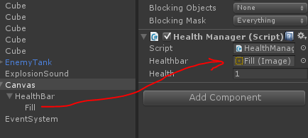
- Find the player tank and open TankControl.
- At the bottom of the code but before the last brace add this code.
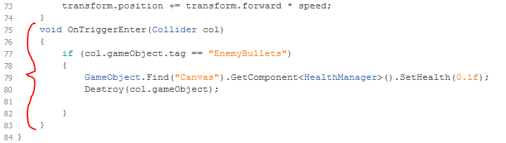
Run the game now and the tanks will reduce your health, until it depletes completely.
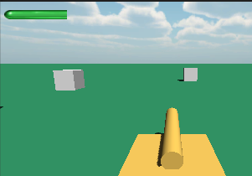
Then an error happens. This is okay – we just need to add a game over screen.
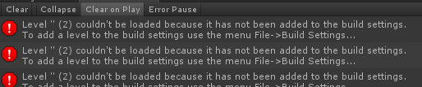

Game Over and Start Screens.
- Save your scene.
- Create a new scene.
- Load the StartGame.jpg image into the UI folder and convert it to a sprite.
- Load the GameOver.jpg image into the UI folder and convert it to a sprite.
- Add a Canvas ->Image
- Drop the StartGame into the Image slot.
- Use the Rect Transform tool and stretch it to full screen using Shift + Alt
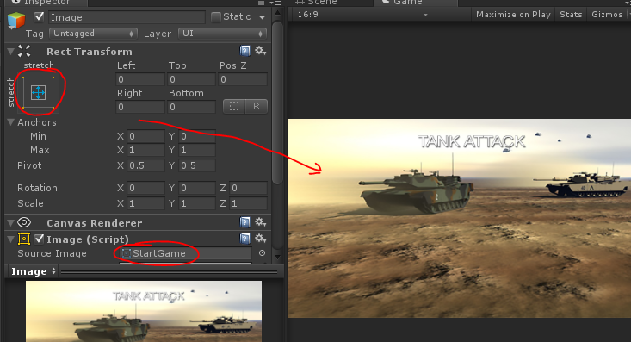
- Under Canvas in the Hierarchy click on UI-Button
- Using the Rect Transform snap it lower bottom centre of screen using Shift+ALR.
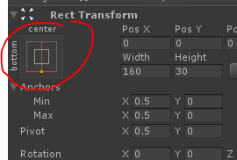
- Change its text to read Start Game.
- Save scene as StartGame
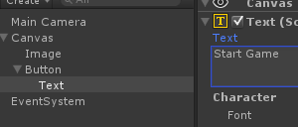
- Click on the Button and then Add Component and add a C# script called ButtonClick
- Add this code.
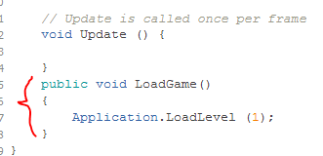
- Save and flick back to Unity.
- Above the ButtonClick component find the OnClick component.
- Click on the + button
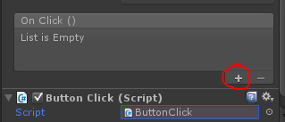
- Drag the Button into the slot (1) – the click on the No Function (2) and select ButtonClick->LoadGame() – (the function you just wrote)
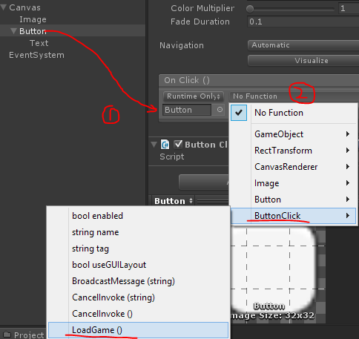
- Save the scene.
- Open File->Build Settings
- Click Add current to make this Scene 0
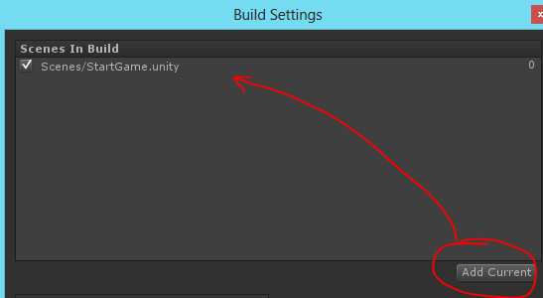
- Load the Level1 scene – or whatever you scene is.
- Click on File ->Build Settings and click on Add Current again to make this Scene 1
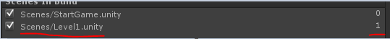
- Load StartGame
- Replace the StartGame graphic with the GameOver graphic.
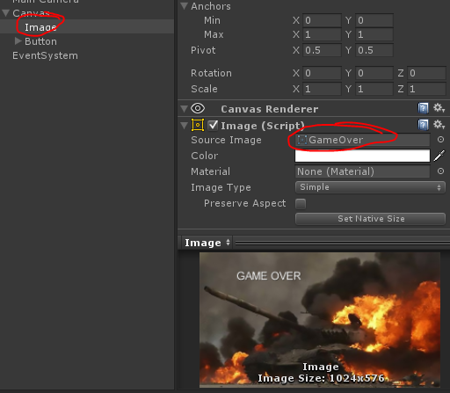
- Save scene AS GameOver.
- Click on File ->Build Settings and click on Add Current again to make this Scene 2
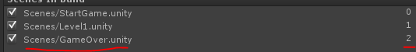
- Load StartGame and run the game.
- Click on the Start Game button
- Get shot and eventually it will go to Game Over.
- Click on the Start Game to restart the game again.

Enemy Take Hits.
- Click on the EnemyTank in the Prefabs folder
- Remove the CubeCollision – you won’t need that anymore.
- Open the EnemyController script in MonoDevelop.
- At the bottom of the code before the last brace add this function.
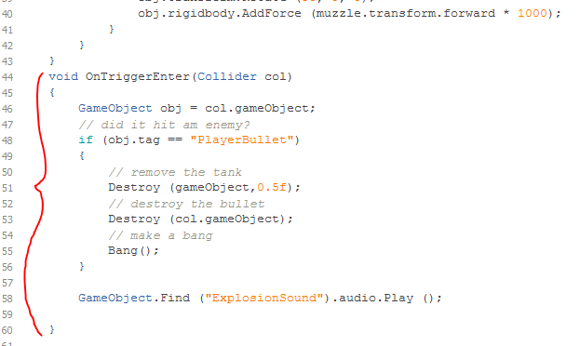
- Below that but before the last brace add this code – this will make some cube debris.
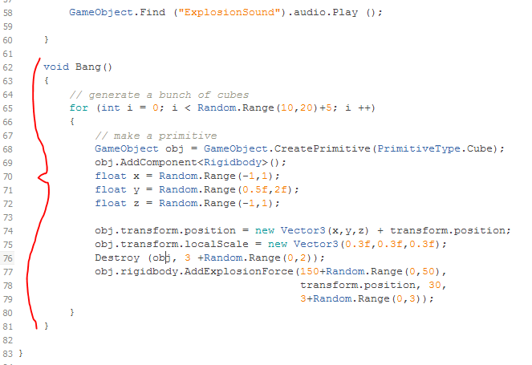
- Save and flick back to Unity.
- Find the Bullet in the Prefabs
- It’s untagged at the moment. Click on the Untagged rollout and select Add Tag
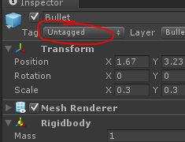
- Add a tag called PlayerBullet.
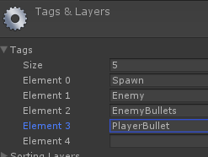
- Then click on the Bullet again and change the tag to PlayerBullet.
Run the game now and you can blow up the tanks, and they throw out a shower of cubes.

Tally tanks and respawn.
- Click on the Canvas and add UI->Text
- Call it Score.
- Change the text part to Score:0
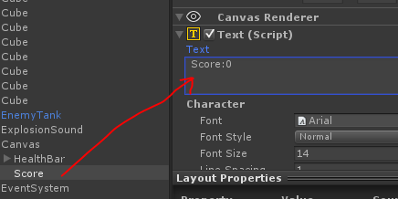
- Place it top right using the Rect Transform using Shift and Alt, and change its font size to a decent size.
- Change it to white.
- Turn Horizontal Overflow and Vertical Overflow to Overflow
- Make it right justified.
- Click on Add Component and add a Shadow
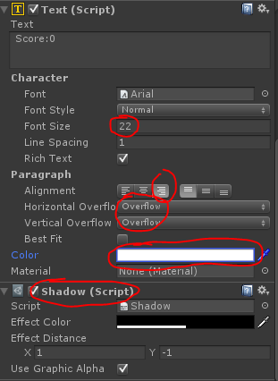
- Should look something like this.
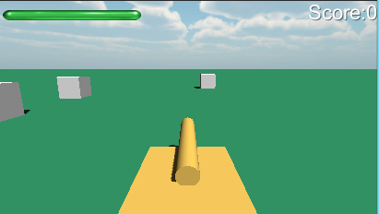
- Open the TankControl script.
- Add this line at the top
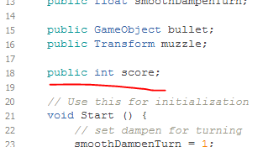
- Open the EnemyController script again.
- Add this line at the top.
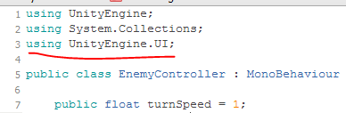
- And at the bottom include this code change in the OnTriggerEnter function before its own brace – Note if you’ve changed the name of your tank replace the word Tank in line 62 and 64 in the example to match yours.
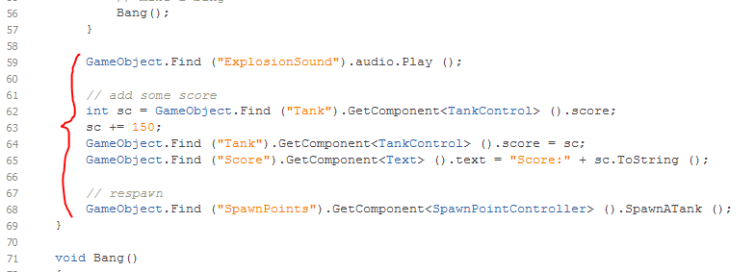
Just double check your SpawnPoints SpawnPointController is using the Prefab version of the EnemyTank and not one in the scene otherwise errors will occurs and eventually you’ll run out of tanks to shoot.
Save the scene
Run the game – and start moving fast. You’ll get shot pretty quick otherwise. The tanks will now respawn – you now have a simple tank game.
