# Tank tutorial Week 5

This week you will add an enemy tank and make it fire at the player. In the next session it will also spawn somewhere else if you destroy it, and handle player hits.

There are several steps

1. Create a series of spawn points
2. Attach those points to the player
3. Add a script to the spawn point controller (the root) to pick a random point to spawn a tank
4. Add a script to the tank to turn to face the player.
5. When the player is within its firing arc it will fire.

## Create a series of spawn points.

Open your current scene to add all the changes.

1. Make an empty game object called SpawnPoints
2. Make this object a child of the Player
3. In the inspector for this object there is a cog with a down arrow. Click on it and click on Reset. This will snap it to the player’s position
4. Make a child of that object as an empty game object called Spawn
5. In the Inspector create a tag called Spawn and assign to the Spawn object
6. Change the icon for the game object to a diamond
7. Duplicate 7 more and place in a ring around the tank a fair distance off so the tanks won’t end up spawning right on top of the player.
8. 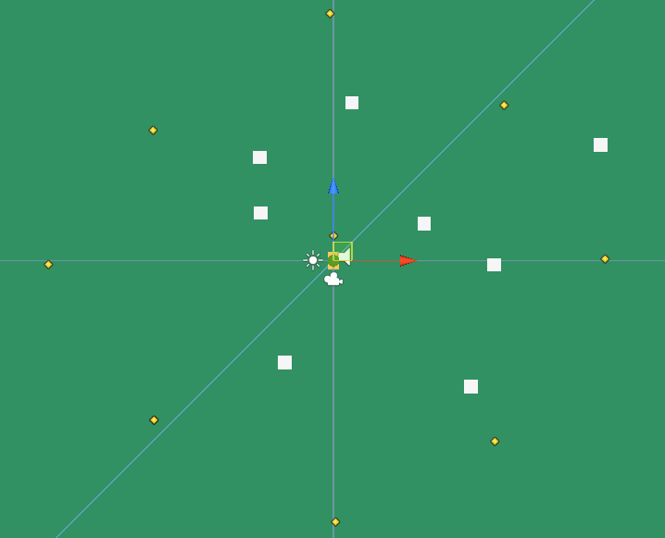

## Spawn Point controller.

1. To the SpawnPoints object add a new C# script and call it SpawnPointController (all one word – capitalised as I have done)
2. Double click on the script to open it in Mono Develop
3. Add this code highlighted – remember the red brace shows you the code to add ONLY. Don’t add the other code you can see. It’s already there.

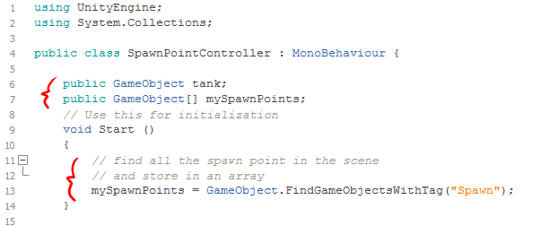

1. Then add this function. Because it’s declared public any other script can access it. You will use it to tell the bullet that blew up the last tank to spawn another one.

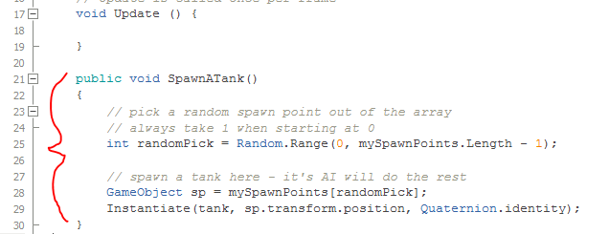

1. Save and flick back to Unity.
2. Run the game to test that all the spawn points are loaded into the SpawnPoints object

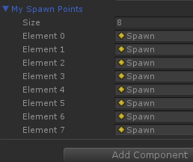

### Adding an Enemy tank.

Now that it’s week 5 you should have created an enemy tank. If not, use the cubes, and when you finished this tutorial replace the cubes with your enemy tank.

For this tutorial I have added a cylinder to my cubes and named it EnemyTank.

1. Make sure you have a muzzle on the end marked with a diamond.

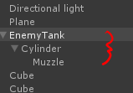

1. Add a Layer and a Tag called Enemy and assign to your tank.

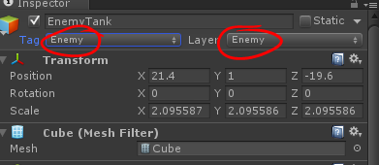

1. My tank looks like this. Yours should look better!
2. 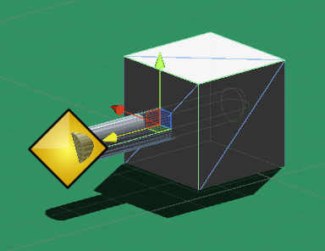
3. Add a new Layer and Tag called EnemyBullets
4. Go into Edit->Project Settings ->Physics and make sure tanks can’t collide with tanks.
5. Also make sure EnemyBullets can’t collide with tanks, each other and vice versa.

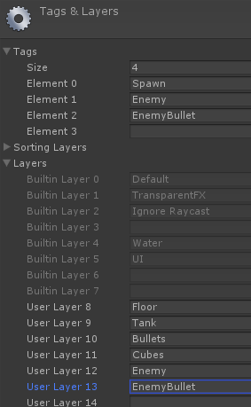 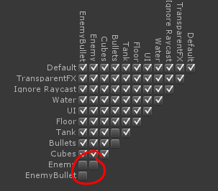

### Add a script to turn and face player.

1. Drag this new tank into your prefabs folder so it can be spawned.
2. Select this prefab using the circle in the slot called Tank in the Spawn Point Controller component.

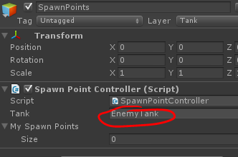

1. Click on the prefabs folder to find the new tank
2. Click on it to change the Inspector to point to this object.
3. Click on Add component and create a new C# script called EnemyController
4. Double click on the script to edit it Mono Developer.
5. Add this code.

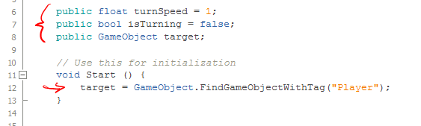

1. Then in the Update method add this code.

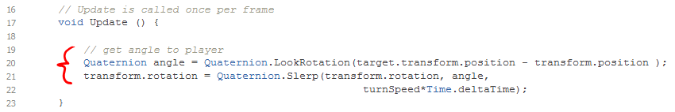

1. Save and switch back to Unity
2. Set the player Tank tag to Player
3. Run the game and watch the Enemy Tank turn toward you.

### Enemy fires when facing player.

This involves making a new bullet (copy the existing bullet) and firing that at the player.

1. Go to the prefabs and duplicate the bullet.
2. Rename it EnemyBullet
3. Change it’s Layer and tag to EnemyBullet(s)
4. Select the EnemyTank
5. Click on the circle at the end of Bullet slot under EnemyController and select EnemyBullet
6. Drag the EnemyTank into the scene
7. Select it’s Muzzle and drag into the muzzle slot of that same tank – this creates a circular reference in the prefab
8. Select the Apply button at the top of the Inspector – this will apply it back to the prefab.
9. Open the EnemyController script and add this code/

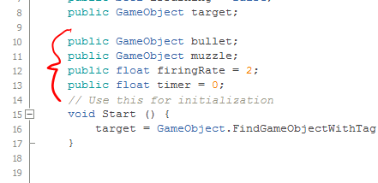

1. In the Update method add this code…

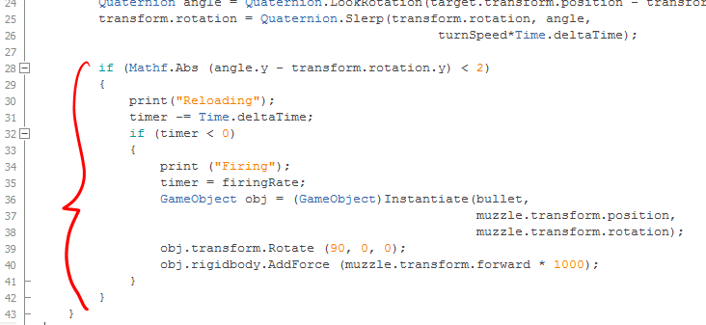

1. Note that line 39 might not be required depending on your bullet, and the rotation of your muzzle node.
2. Save and flick back to Unity.
3. Drag out a few tanks around the scene and see how they behave.
4. They will shoot cubes, but not each other.