Tank tutorial week 1.

# Overview.

You are going to make a tank game like Battlezone. (watch video - BattleZoneArcade)

In the original game the machine had a stand upright cabinet, two joysticks and a place to put your head to create an immersive environment.

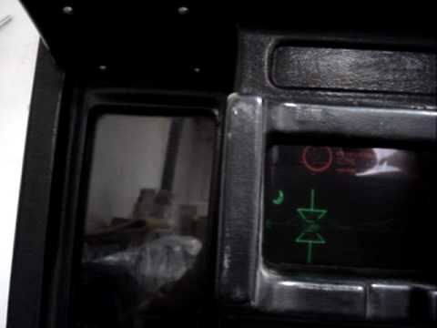 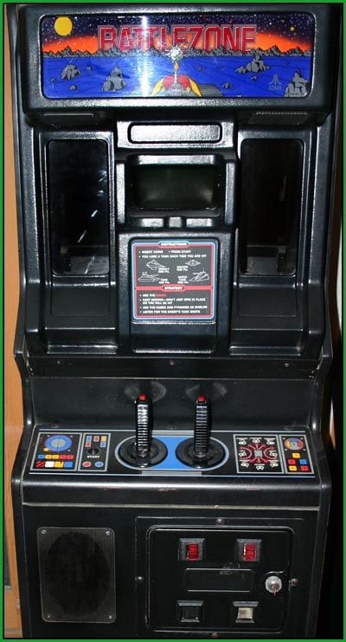 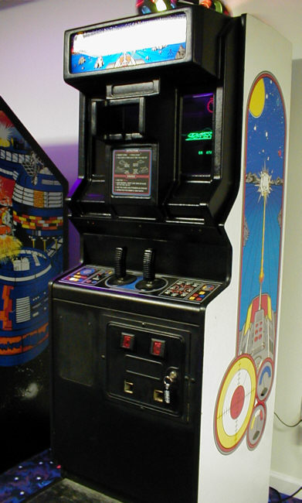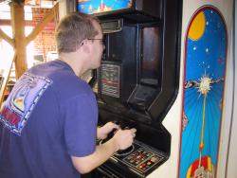 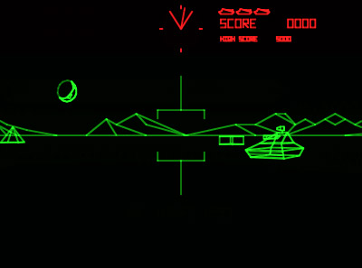

You will re-create this game and extend the 2D experience into 3D using the Oculus Rift later this semester.

This video shows the latest iteration of BattleZone in VR. (watch video BattleZoneReboot)

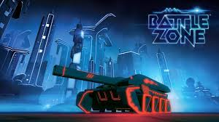

There have been many version. There was even a multiplayer version. You will create a new version too. (watch video BattleZone1998)

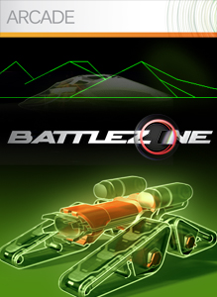 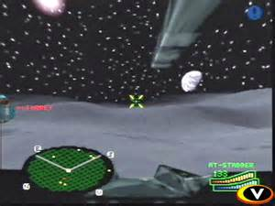

# Building the scene.

Today you will work on controlling the tank in a 3D environment. You’ll need a few elements to get started. You’ll make a skybox, ground, light, tank, turret and camera.

1. Open up Unity and make a new project in 3D under a folder called Tank1.
2. Make a folder structure like this.

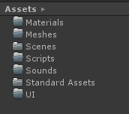

1. Create a cube and then create a cylinder. This will be your tank.
2. Drop the camera into the objects hierarchy and move back so you can see the ‘tank’ in front of you.

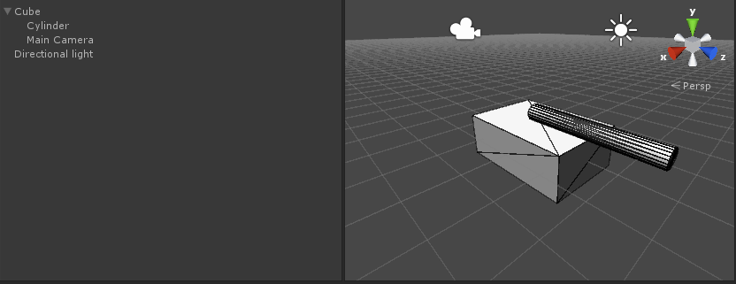

1. Add a plane and make it 1000,1000,1000
2. Select the Directional light and turn on shadows.

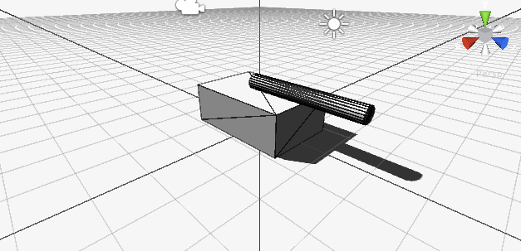

1. Save under Scenes and call it Level1.
2. Add the skyboxes pack (right click on Assets, select Import Package - >Skyboxe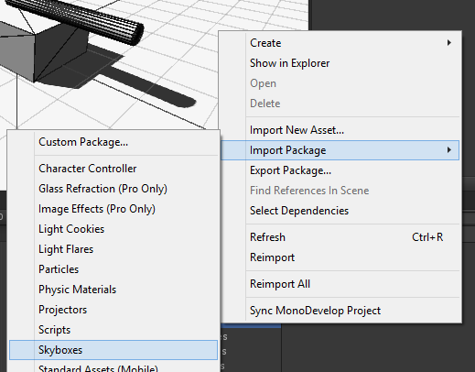
3. Select Import once it’s decompressed.
4. To add a skydome click on the Edit menu and select Render Settings
5. Then find the Skybox material and select a skybox.

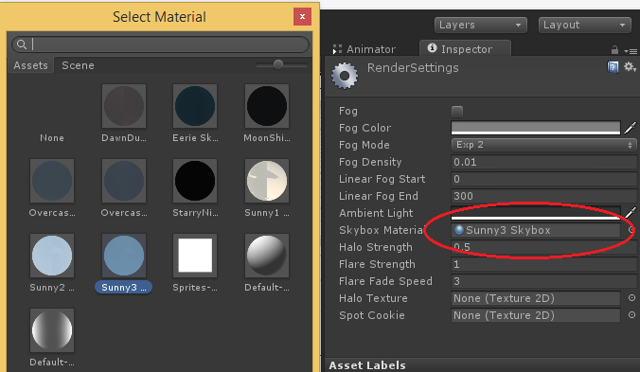

1. If done right it should look like this.

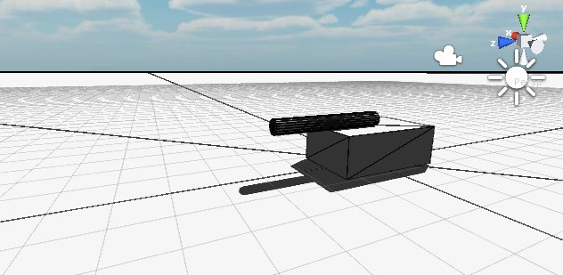

1. Create a new material called ground and one called tank in the materials folder.
2. You can change the colour using the swatch upper right. Make the ground one colour and the tank another. Then drag the sphere icon onto each of the components of the tank using the tank material and repeat for the ground and ground material. It should look like this.

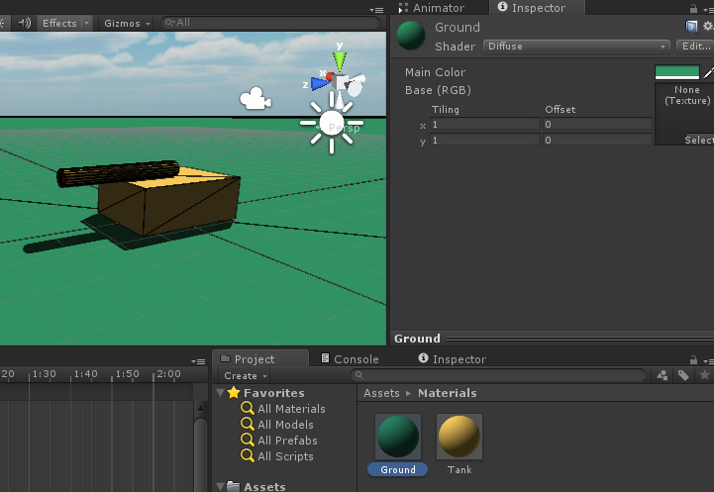

1. Save and run. Your remarkable game should look like this. Stunning hey? :D

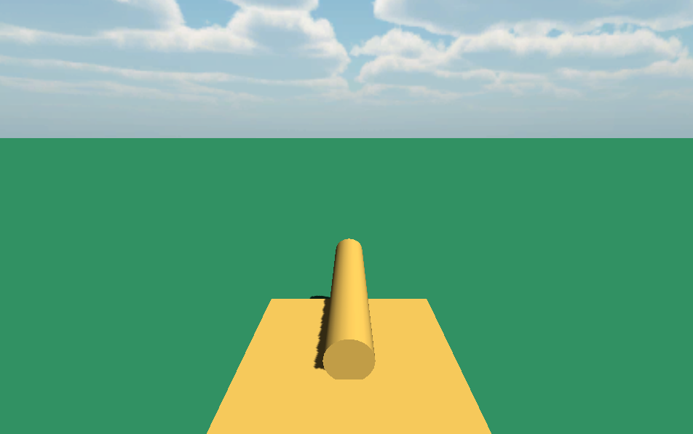

## Coding the movement.

## 

The tank can be controlled using two sticks as in the Tafe arcade machine version, by a single set of cursor keys or WASD and also by joystick or using touch controls on a mobile. You will cover all of these during the semester. For now you will just use the WASD and Cursor keys which incidentally work for joystick as well.

1. Click on the Cube and rename it Tank
2. In the inspector for the Tank click on Add Component and type in TankControl.
3. Click on the NewScript part of the component.
4. Make sure it’s of type CSharp using the dropdown and then click on Create and Add

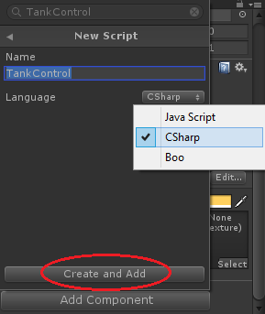

1. Double click on the newly created script and you will edit it in Mono Develop.

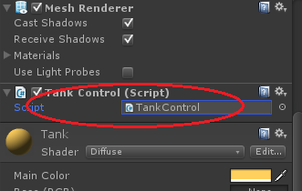

### Adding Variables

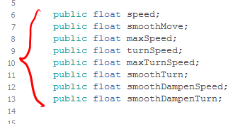

You’ll need a few **variables** to keep control of the tank over time.

You will need several **variable** types. These are called **data types.**

To keep track of the **speed** we’ll need a **data type** called **float**.

You will also need to track the time it takes for the tank to speed up and slow down. That will also be a **float** called **smoothMove**.

You will then need to keep track of the maximum forward and maximum backward speed the tank can travel. For now you will need one of type **float** called **maxSpeed.**

Then you will need a dampening **float** called **smoothDampenSpeed** which adjusts how quickly the speed gets the value you want it to – or how quickly it accelerates and decelerates.

Next you will need to set how fast the tank turns. You will need a data type of **float** called **turnSpeed.**

You will also need to keep track of the maximum turn rate using a **float** called **maxTurnSpeed.**

You will need a **float** called **smoothTurn** to control the ramp up of speed from 0 to **maxTurnSpeed**.

You will also need a **float** called **smoothDampenTurn** to handle when you release the rotation keys (left and right) so the tank slows turning down to stop or the turn speed increases to maxTurnSpeed.

Another **data type** you will use is a **Vector3** to control **translation** through space and **Quaternion** to control **rotation** around a world position.

Confused? Cool :D

1. At the top of the file add the speed variable we just discussed. In C# you specify the assessor, the type then the name, and end with a semi-colon.

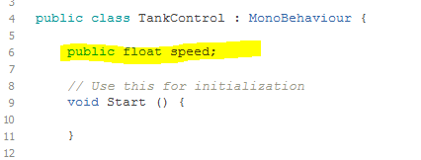

1. The accessor called public allows other scripts to see these variables and they also appear in the inspector so you can change them later.
2. Press CTRL + S to save and flick back to the Unity Editor and look at the Tank again, specifically the TankControl script and see that the speed variable has been added.

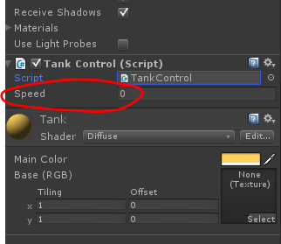

1. Just for a test change it to private in Mono Develop.

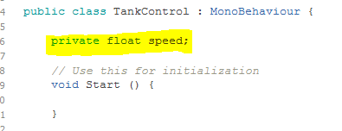

1. Save it and flick back to the Unity Editor.
2. It’s now disappeared. It’s still accessible by the code itself, but only this script, not any others.

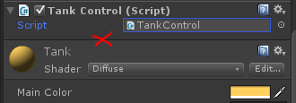

1. Change it back to public and add all the others.



## Understanding script flow and turning.

Unity scripts operate in a particular way. All variables are created as you have written just before, then the Start function (or more correctly method) runs, then the Update function runs.

So with this in mind you will set some default values for some of the variables in Start and then you will set some values in the inspector.

1. In Mono Develop add this code inside the **Start** function. Be care to put all the code in between the { } braces and to put a semi-colon ( ; ) at the end of each line.

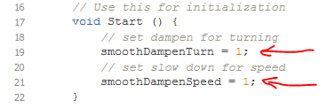

1. Save it and then go back to Unity.
2. Set the values in the inspector as follows. This will cover the move settings too.

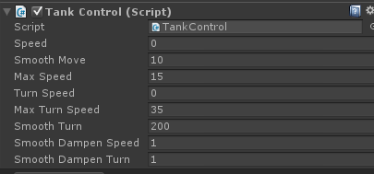

1. Go back to Mono Develop as add this code to the **Update** function this time being careful to put all code inside the {} braces and ending each line with a semi-colon ( ; )

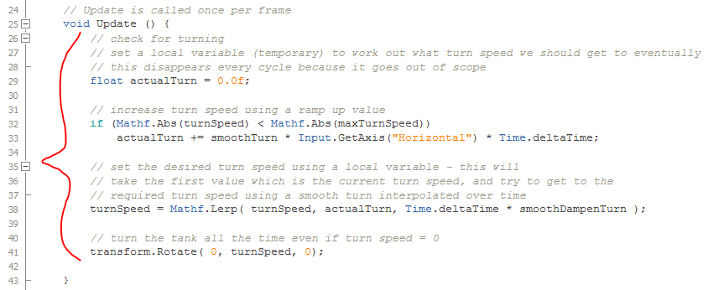

1. Save the file in Mono Develop.
2. Return to the Unity Editor.
3. Run the game. Turn and you will find it smoothly speeds up and slows down rather than instantly going at a full turn speed. If you turn off the Maximise On Play button you can see the Inspector value for turn Speed change as well.

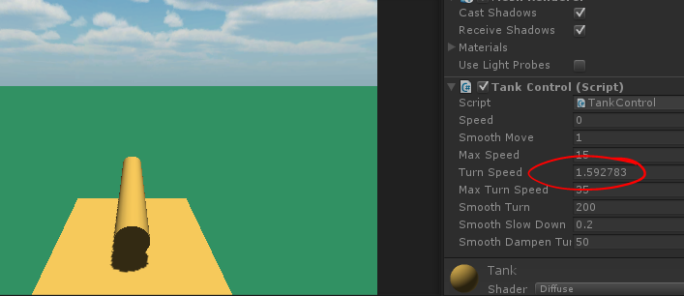

### Moving the tank.

Moving the tank uses the same principal as turning the tank. It slides the speed up to the value of the Vertical input this time, and when you release it smoothly slows down.

1. Go to Mono Develop and UNDER!! the code you have already entered to turn it add this code to move it smoothly. DON’T add lines 40 and 41 they are already there are it’s just showing you where to add the code.

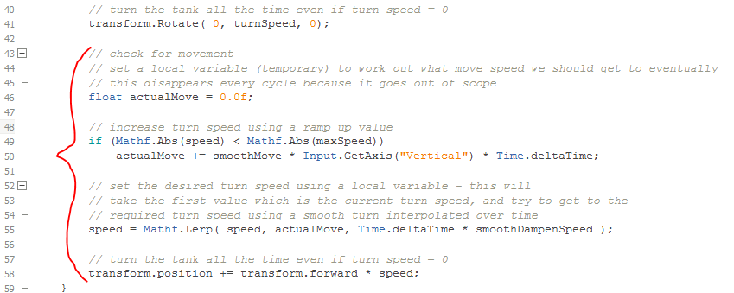

1. Save the file in Mono Develop.
2. Return to the Unity Editor.
3. Split the Scene and Game view so you can see both below and roll the mouse wheel to zoom out a bit on the tank in the Scene view. This is because there is not detail on the plane and so you can’t see when the tank moves unless you watch it in the Scene view.

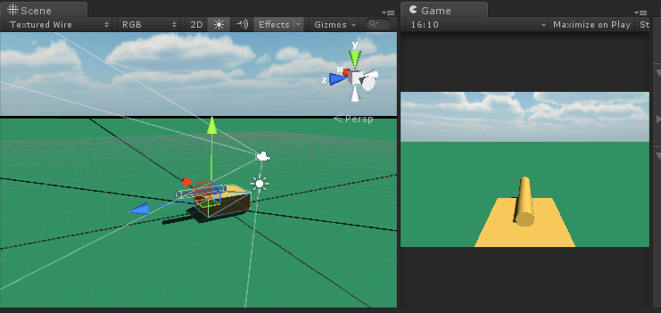

1. Run the game now and move and turn. You will see it moves and turns smoothly. Adjust the variables in the inspector to suit. If you do this during Play right click on the Tank Controller in the inspector, and select Copy Component while the game is still running and you are happy with the settings.

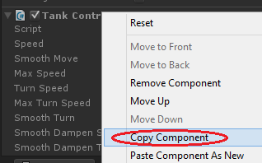

1. Then stop the game, right click on the Tank Controller and click on Paste Component VALUES. This will retain the settings.

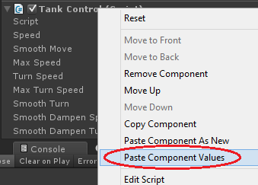

1. Save you game.

### Adding some visual detail.

You can see that the tank is moving only turning. You will need to add some objects to create this effect.

1. Add a cube to the scene.
2. Duplicate it many time and move the copies around the scene.

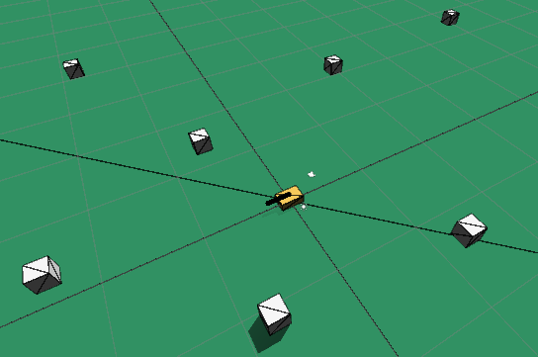

1. Run it again after turning on Maximising On Play in the Game window and run it full screen.
2. You will now be able to see the tank is moving as well as turning. Save you work for next week.

